DHCP:

Dynamic Host Configuration Protocol (DHCP) is a network protocol
that enables a server to automatically assign an IP address to a computer
from a defined range of numbers (i.e., a scope) configured for a given network.

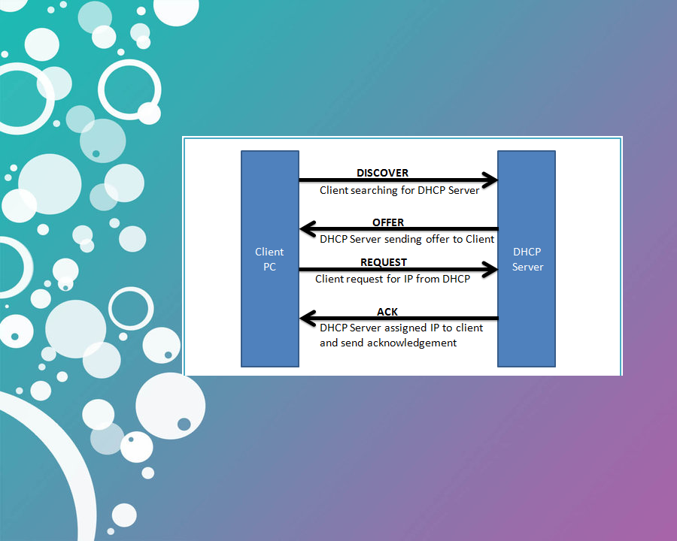

https://www.cisco.com/c/en/us/support/docs/ip/routing-information-protocol-rip/13788-3.html

